RATIO AND PROPORTION
Pearson Edexcel - Tuesday 19 May 2020 - Paper 1 (Non-Calculator) Higher Tier
1.
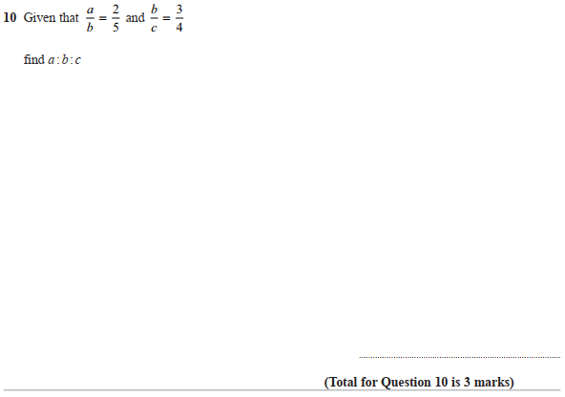

Pearson Edexcel – Thursday 4 June 2020 - Paper 2 (Calculator) Higher Tier
2.
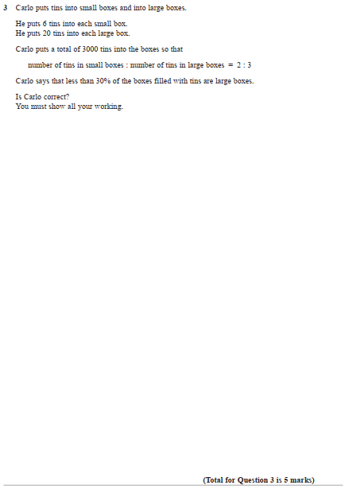
Pearson Edexcel – Monday 8 June 2020 - Paper 3 (Calculator) Higher Tier
3.

Pearson Edexcel - Tuesday 21 May 2019 - Paper 1 (Non-Calculator) Higher Tier
4.
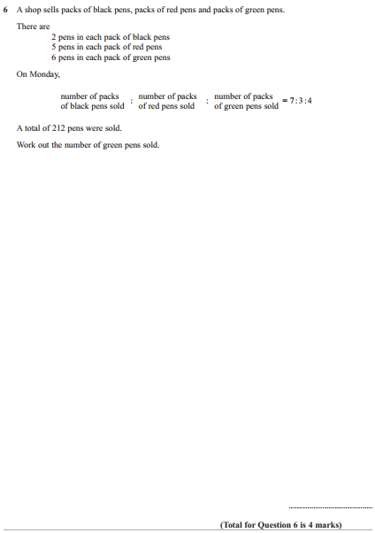

Pearson Edexcel - Tuesday 21 May 2019 - Paper 1 (Non-Calculator) Higher Tier
5.
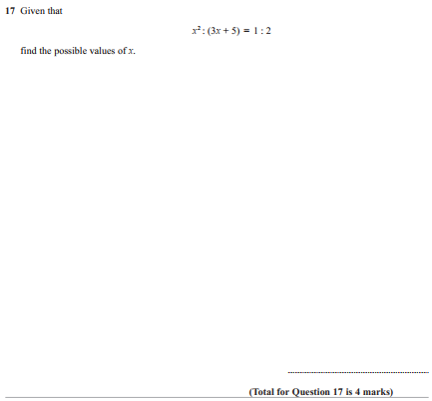

Pearson Edexcel - Thursday 6 June 2019 - Paper 2 (Calculator) Higher Tier
6.
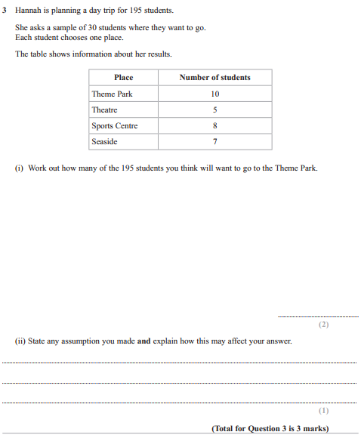

Pearson Edexcel - Thursday 6 June 2019 - Paper 2 (Calculator) Higher Tier
7.
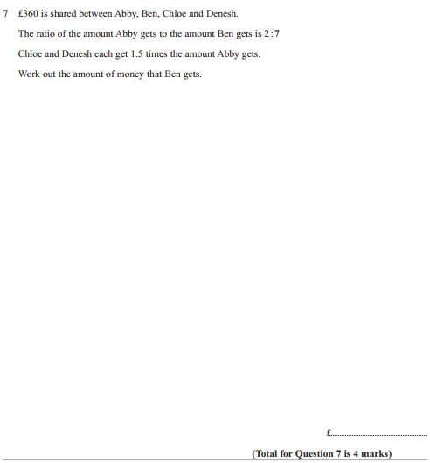

Pearson Edexcel - Thursday 6 June 2019 - Paper 2 (Calculator) Higher Tier
8.
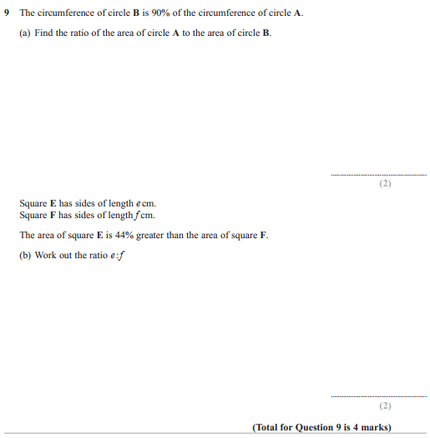

Pearson Edexcel - Thursday 6 June 2019 - Paper 2 (Calculator) Higher Tier
9.
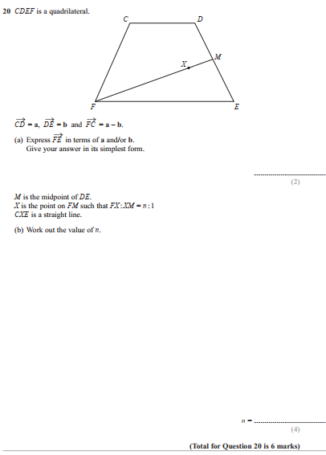

Pearson Edexcel - Tuesday 6 November 2018 - Paper 1 (Non-Calculator) Higher Tier
10.
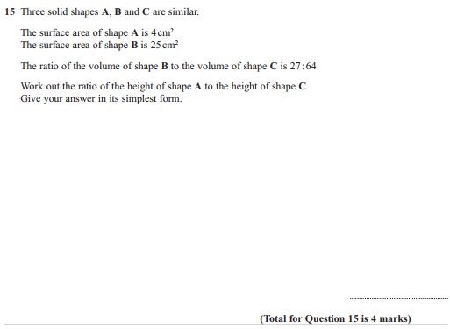

Pearson Edexcel - Tuesday 6 November 2018 - Paper 1 (Non-Calculator) Higher Tier
11.
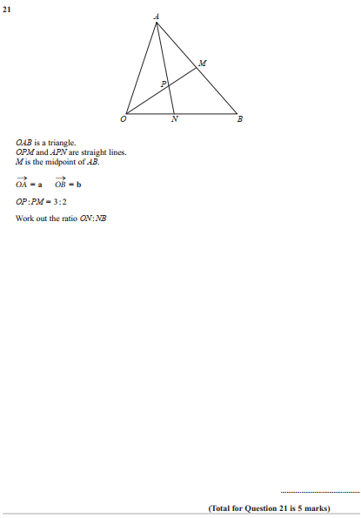
Pearson Edexcel - Thursday 8 November 2018 - Paper 2 (Calculator) Higher Tier
12.

Pearson Edexcel - Thursday 24 May 2018 - Paper 1 (Non-Calculator) Higher Tier
13.
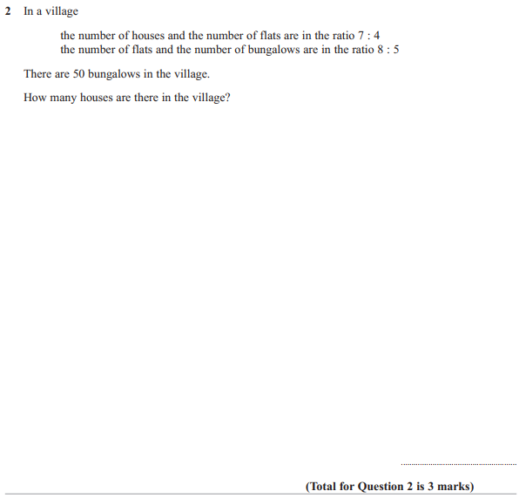

Pearson Edexcel - Thursday 7 June 2018 - Paper 2 (Calculator) Higher Tier
14.

Pearson Edexcel - Thursday 7 June 2018 - Paper 2 (Calculator) Higher Tier
15.
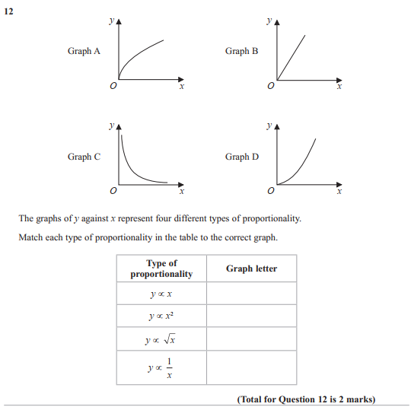

Pearson Edexcel - Thursday 2 November 2017 - Paper 1 (Non-Calculator) Higher Tier
16.
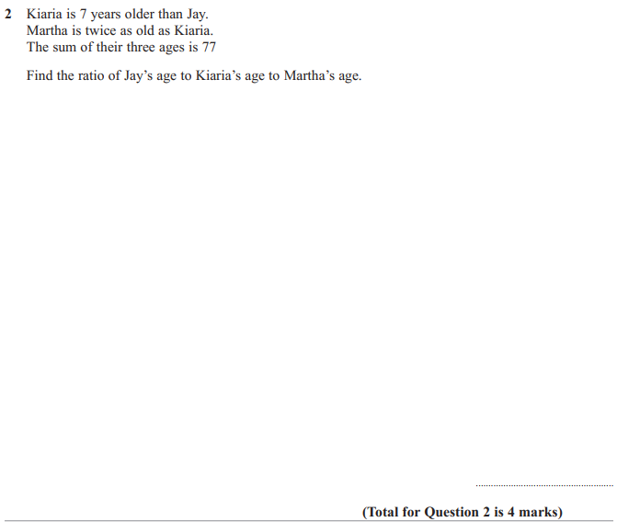

Pearson Edexcel - Thursday 2 November 2017 - Paper 1 (Non-Calculator) Higher Tier
17.
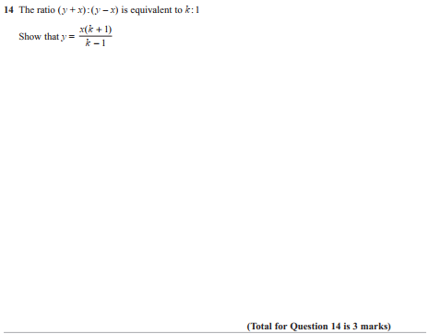

Pearson Edexcel - Wednesday 8 November 2017 - Paper 3 (Calculator) Higher Tier
18.
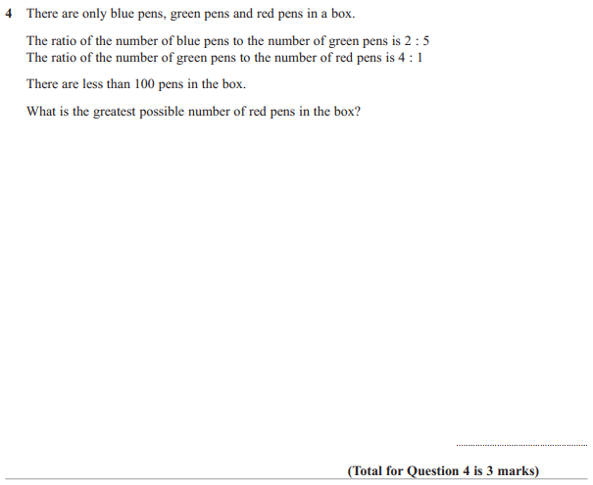

Pearson Edexcel - Wednesday 8 November 2017 - Paper 3 (Calculator) Higher Tier
19.
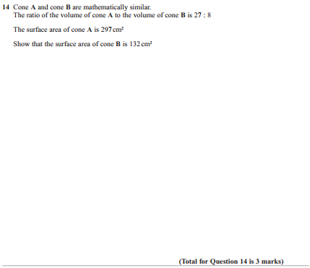

Pearson Edexcel - Thursday 25 May 2017 - Paper 1 (Non-Calculator) Higher Tier
20.
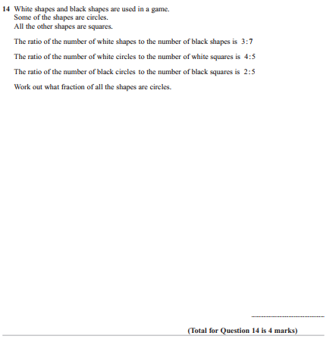

Pearson Edexcel - Thursday 25 May 2017 - Paper 1 (Non-Calculator) Higher Tier
21.
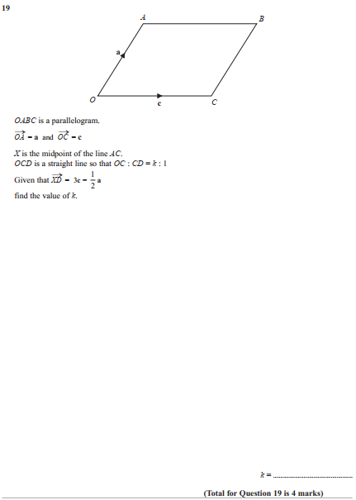

Pearson Edexcel - Tuesday 13 June 2017 - Paper 3 (Calculator) Higher Tier
22.
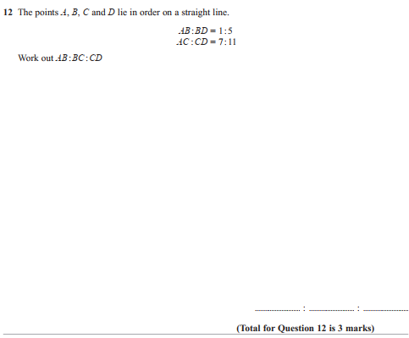
Pearson Edexcel - Specimen Papers Set 2 - Paper 2 (Calculator) Higher Tier
23.
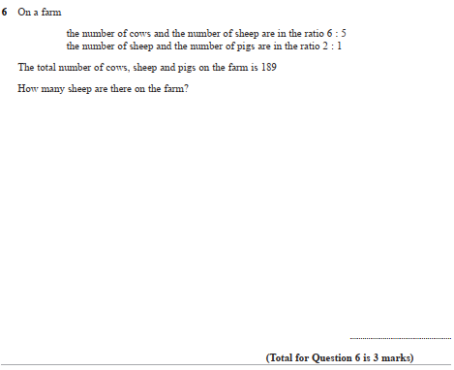
Pearson Edexcel - Specimen Papers Set 2 - Paper 2 (Calculator) Higher Tier
24.

Pearson Edexcel - Specimen Papers Set 2 - Paper 3 (Calculator) Higher Tier
25.
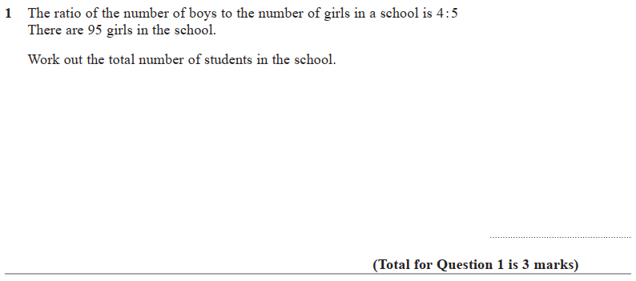

Pearson Edexcel - Specimen Papers Set 2 - Paper 3 (Calculator) Higher Tier
26.
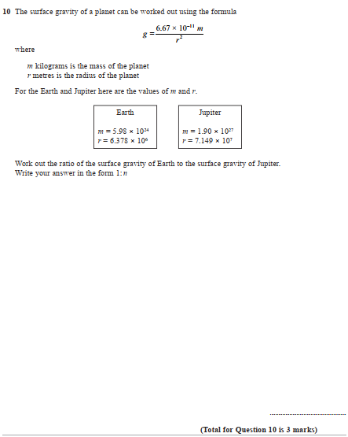

Pearson Edexcel - Specimen Papers Set 1 - Paper 1 (Non-Calculator) Higher Tier
27.
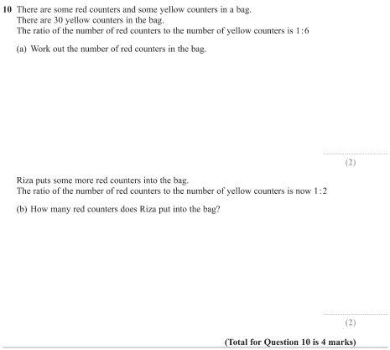
Pearson Edexcel - Sample Paper 2 - (Calculator) Higher Tier
28.
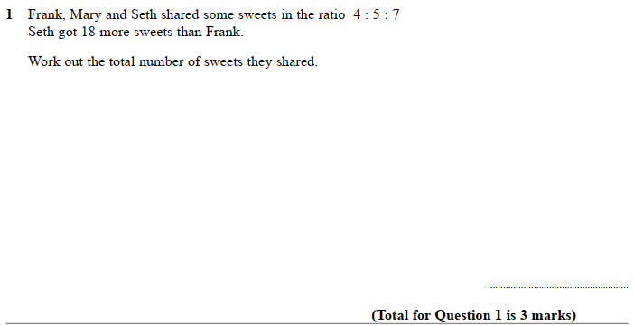
Pearson Edexcel - Sample Paper 2 - (Calculator) Higher Tier
29.
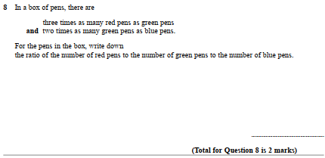
Pearson Edexcel - Thursday 9 June 2016 - Paper 2 (Calculator) Higher Tier
30.
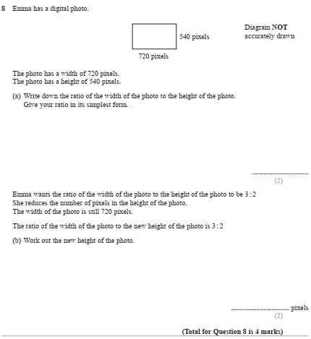
Pearson Edexcel - Wednesday 4 November 2015 - Paper 1 (Non-Calculator) Higher Tier
31.
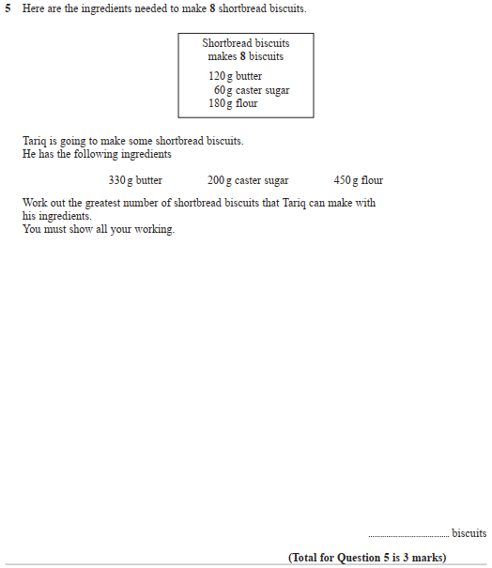

Pearson Edexcel - Friday 6 November 2015 - Paper 2 (Calculator) Higher Tier
32.
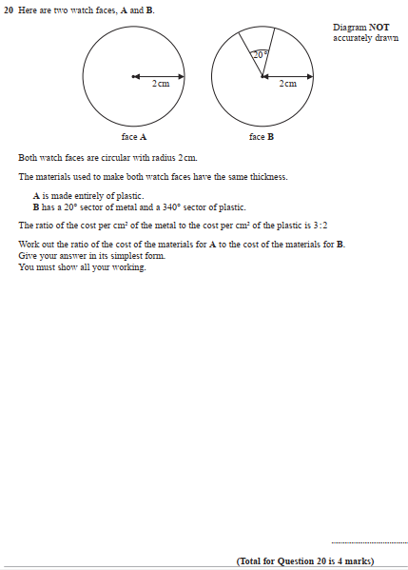

Pearson Edexcel - Monday 8 June 2015 - Paper 2 (Calculator) Higher Tier
33.
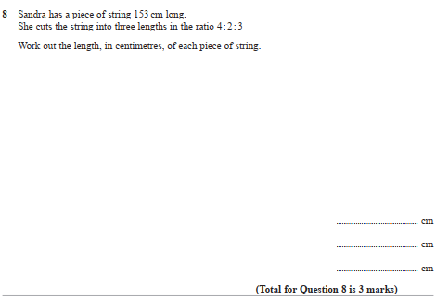
Pearson Edexcel - Friday 8 November 2013 - Paper 2 (Calculator) Higher Tier
34.
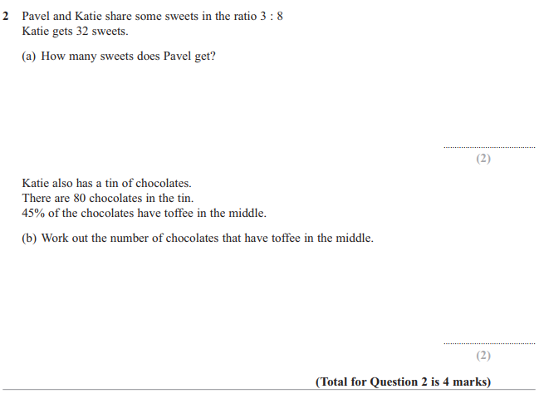
Pearson Edexcel - Friday 14 June 2013 - Paper 2 (Calculator) Higher Tier
35.
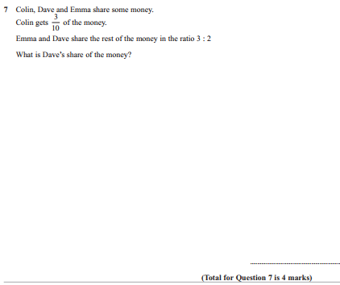

Pearson Edexcel - Thursday 28 February 2013 - Paper 1 (Non-Calculator) Higher Tier
36.
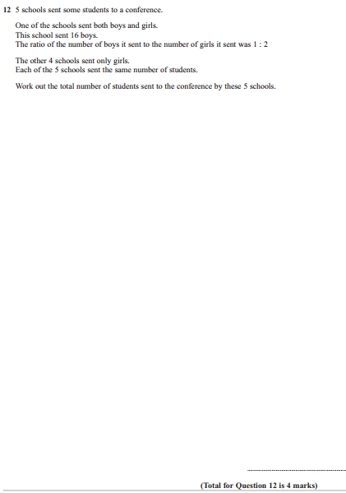

Pearson Edexcel - Tuesday 6 November 2012 - Paper 1 (Non-Calculator) Higher Tier
37.
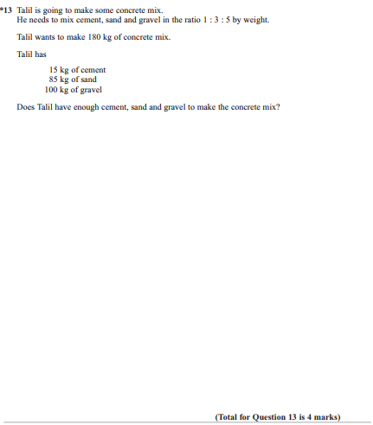

Pearson Edexcel - Thursday 8 November 2012 - Paper 2 (Calculator) Higher Tier
38.
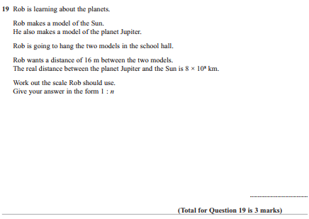

Pearson Edexcel - Friday 2 March 2012 - Paper 3 (Non-Calculator) Higher Tier
39.
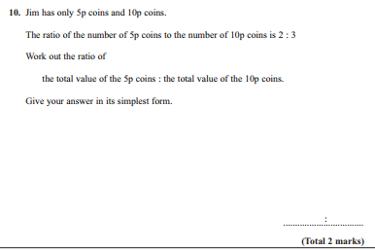

Pearson Edexcel - Monday 5 March 2012 - Paper 4 (Calculator) Higher Tier
40.
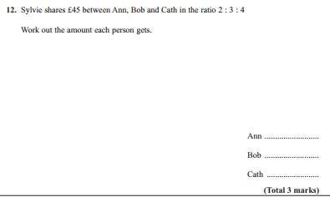

Pearson Edexcel - Tuesday 9 November 2010 - Paper 3 (Non-Calculator) Higher Tier
41.
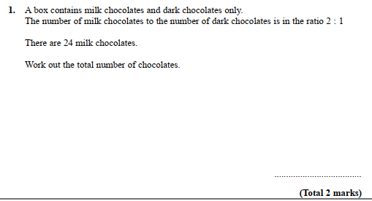

Pearson Edexcel - Tuesday 10 November 2009 - Paper 4 (Calculator) Higher Tier
42.
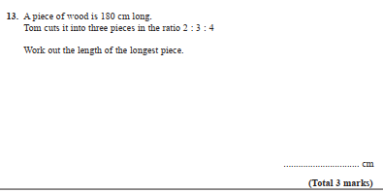
OCR GSCE – Tuesday 3 November 2020 – Paper 4 (Calculator) Higher Tier
43.
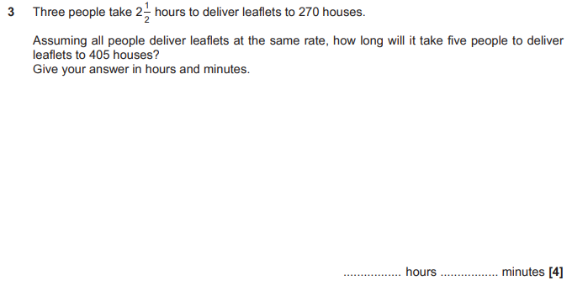

OCR GSCE – Tuesday 3 November 2020 – Paper 4 (Calculator) Higher Tier
44.
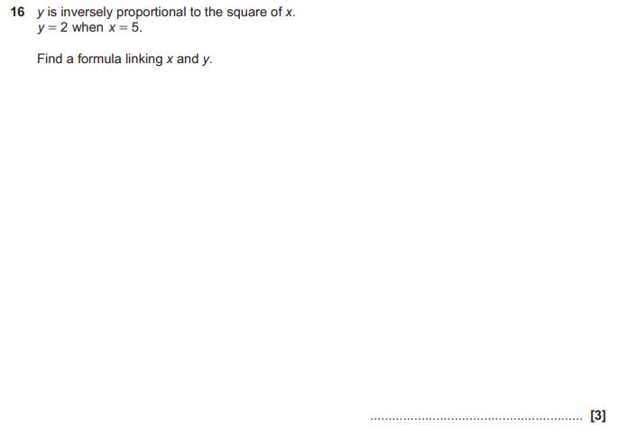

OCR GSCE – Thursday 5 November 2020 – Paper 5 (Non-Calculator) Higher Tier
45.
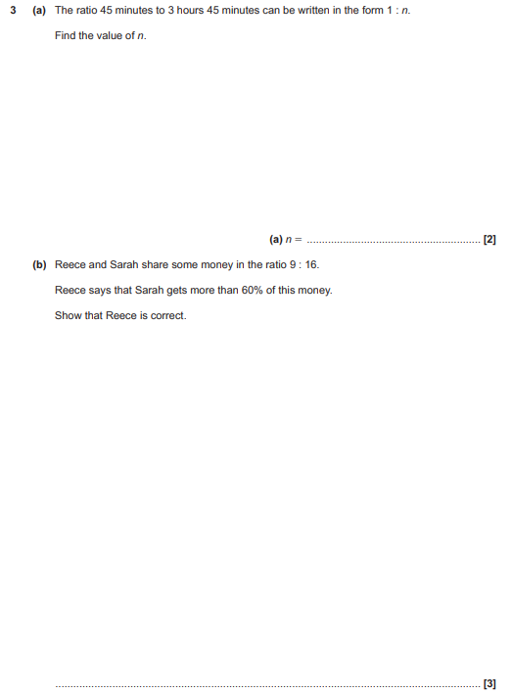

OCR GSCE – Monday 9 November 2020 – Paper 6 (Calculator) Higher Tier
46.
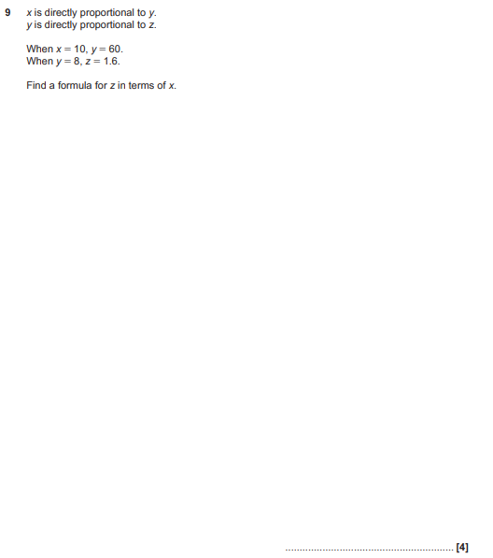

OCR GSCE – Tuesday 5 November 2019 – Paper 4 (Calculator) Higher Tier
47.
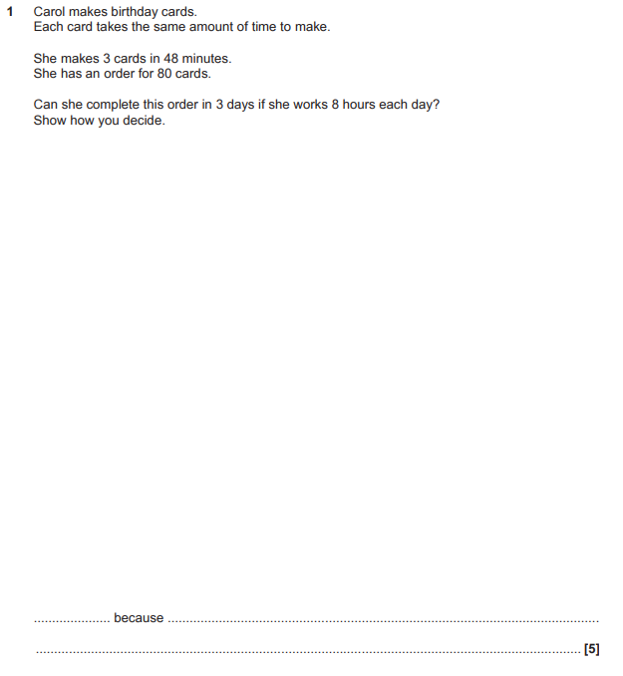

OCR GSCE – Tuesday 5 November 2019 – Paper 4 (Calculator) Higher Tier
48.
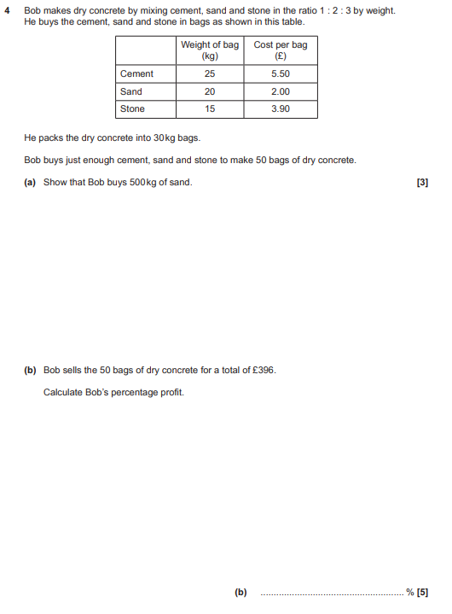

OCR GSCE – Tuesday 5 November 2019 – Paper 4 (Calculator) Higher Tier
49.
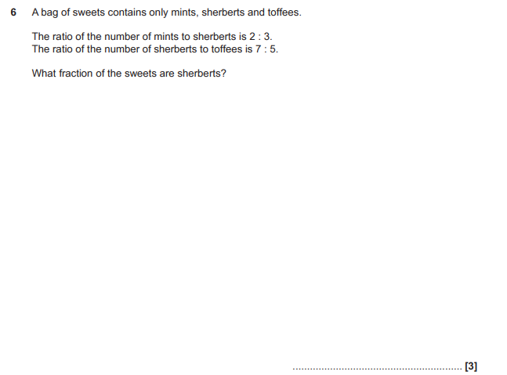

OCR GSCE – Thursday 7 November 2019 – Paper 5 (Non-Calculator) Higher Tier
50.
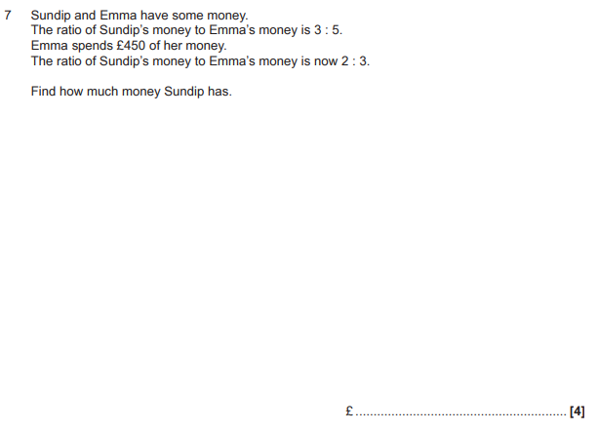

OCR GSCE – Thursday 7 November 2019 – Paper 5 (Non-Calculator) Higher Tier
51.
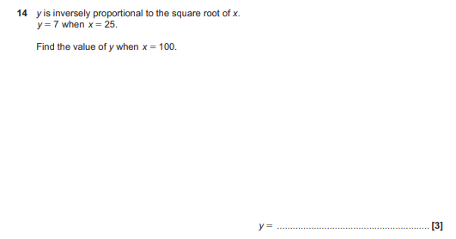

OCR GSCE – Tuesday 21 May 2019 – Paper 4 (Calculator) Higher Tier
52.
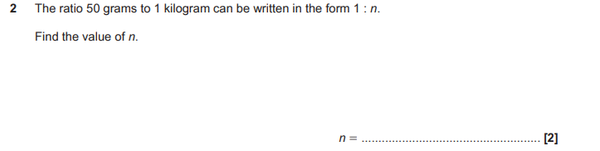
OCR GSCE – Tuesday 21 May 2019 – Paper 4 (Calculator) Higher Tier
53.
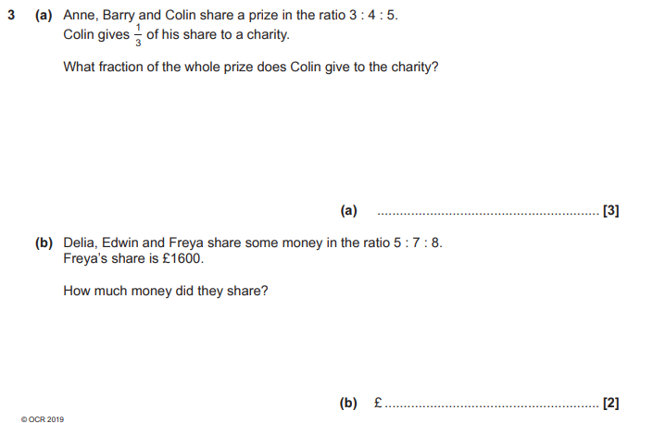

OCR GSCE – Tuesday 21 May 2019 – Paper 4 (Calculator) Higher Tier
54.
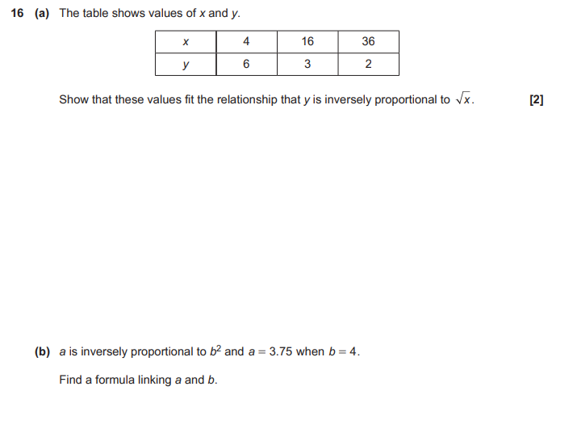

OCR GSCE – Thursday 6 June 2019 – Paper 5 (Non-Calculator) Higher Tier
55.
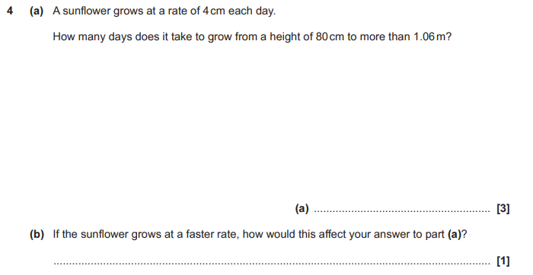
OCR GSCE – Tuesday 6 November 2018 – Paper 4 (Calculator) Higher Tier
56.
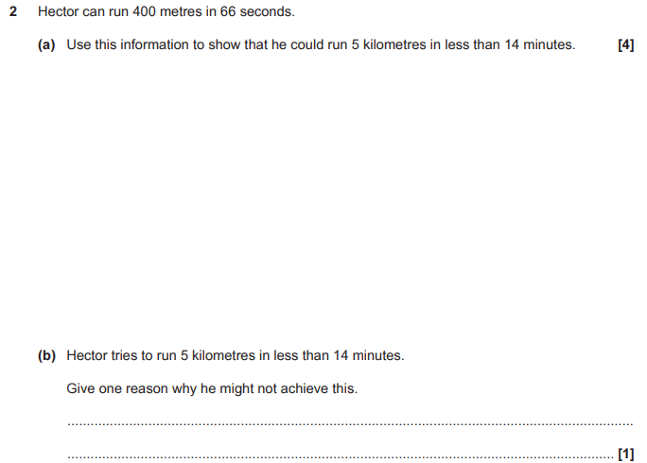

OCR GSCE – Tuesday 6 November 2018 – Paper 4 (Calculator) Higher Tier
57.
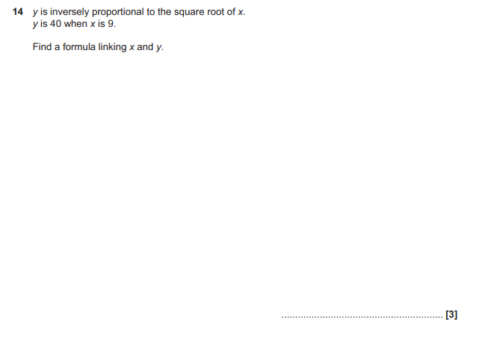

OCR GSCE – Tuesday 6 November 2018 – Paper 4 (Calculator) Higher Tier
58.
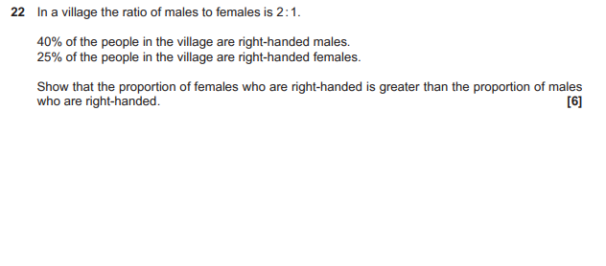
OCR GSCE – Thursday 8 November 2018 – Paper 5 (Non-Calculator) Higher Tier
59.
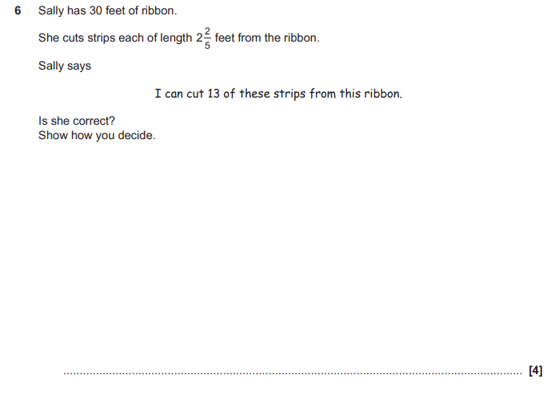
OCR GSCE – Thursday 8 November 2018 – Paper 5 (Non-Calculator) Higher Tier
60.
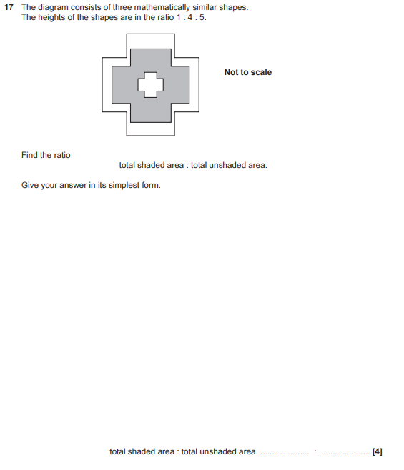

OCR GSCE – Monday 12 November 2018 – Paper 6 (Calculator) Higher Tier
61.
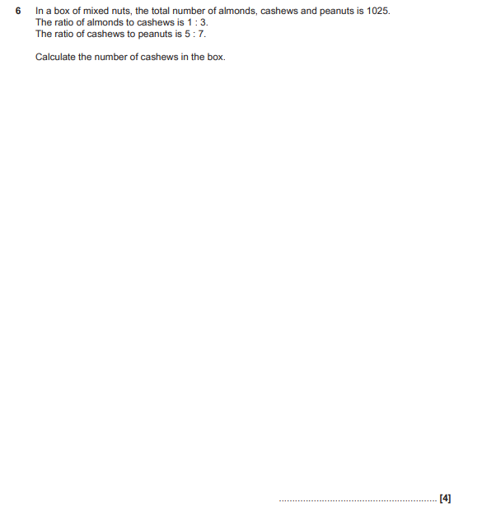

OCR GSCE – Monday 12 November 2018 – Paper 6 (Calculator) Higher Tier
62.
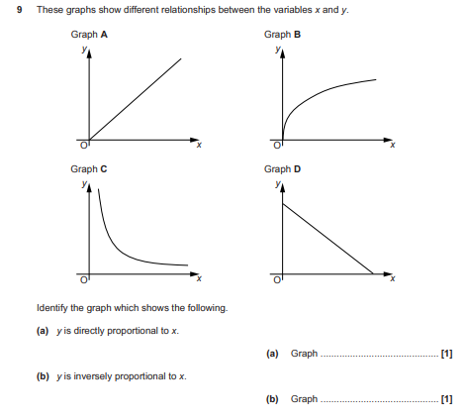

OCR GSCE – Thursday 24 May 2018 – Paper 4 (Calculator) Higher Tier
63.
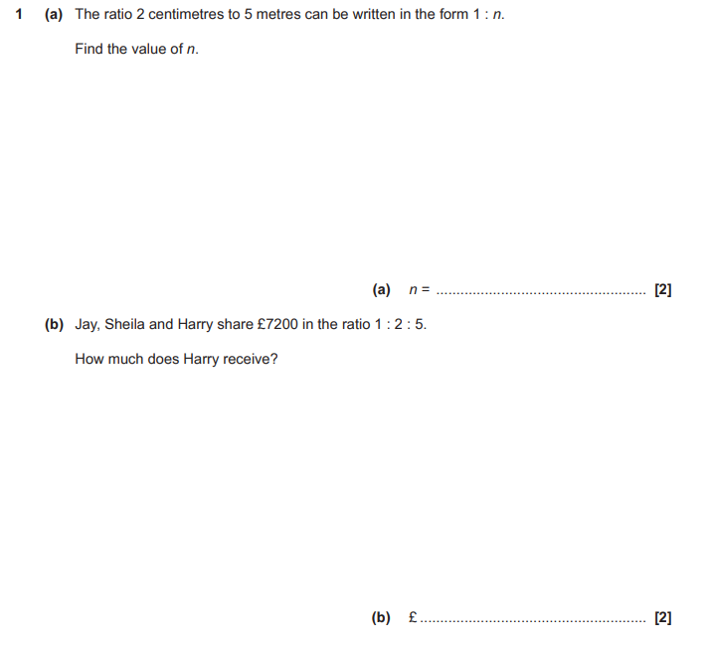

OCR GSCE – Thursday 24 May 2018 – Paper 4 (Calculator) Higher Tier
64.
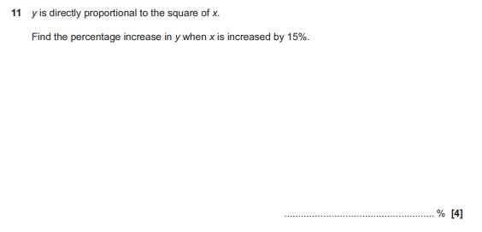

OCR GSCE – Thursday 7 June 2018 – Paper 5 (Non - Calculator) Higher Tier
65.
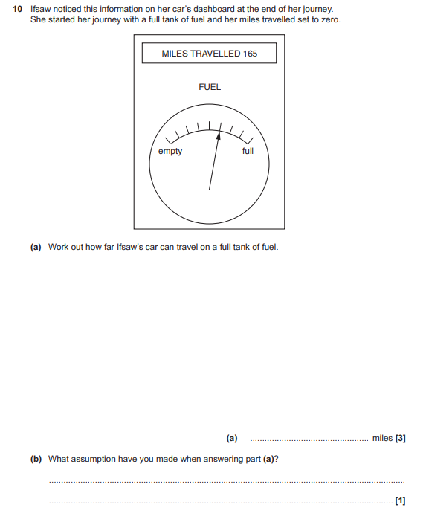

OCR GSCE – Thursday 7 June 2018 – Paper 5 (Non - Calculator) Higher Tier
66.
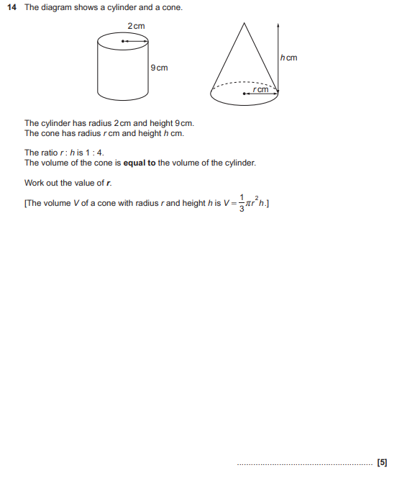

OCR GSCE – Tuesday 12 June 2018 – Paper 6 (Calculator) Higher Tier
67.
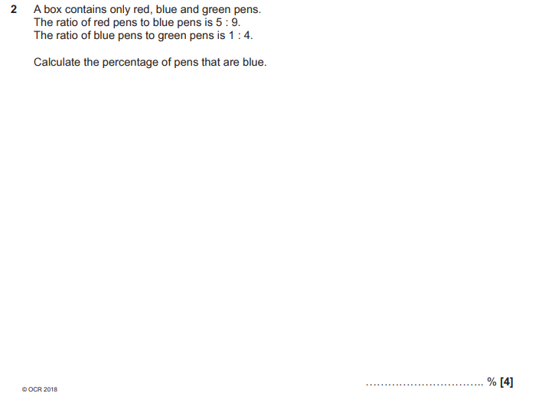

OCR GSCE – Tuesday 12 June 2018 – Paper 6 (Calculator) Higher Tier
68.
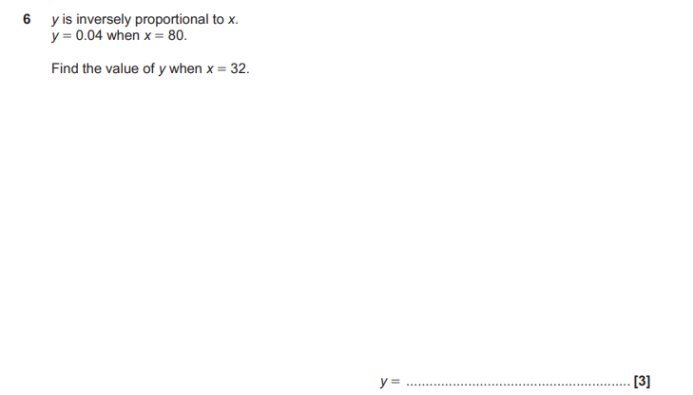

OCR GSCE – Tuesday 12 June 2018 – Paper 6 (Calculator) Higher Tier
69.
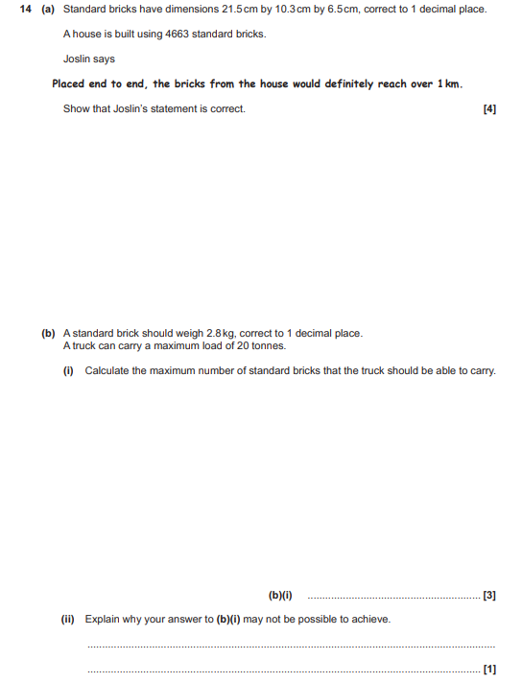

OCR GSCE – Tuesday 2 November 2017 – Paper 4 (Calculator) Higher Tier
70.
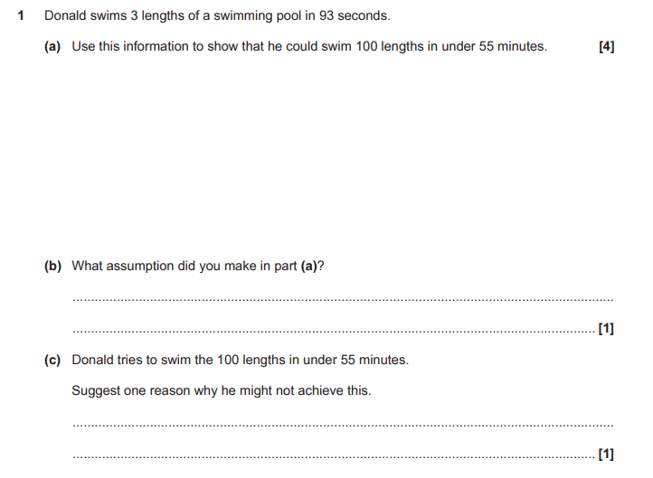

OCR GSCE – Tuesday 2 November 2017 – Paper 4 (Calculator) Higher Tier
71.
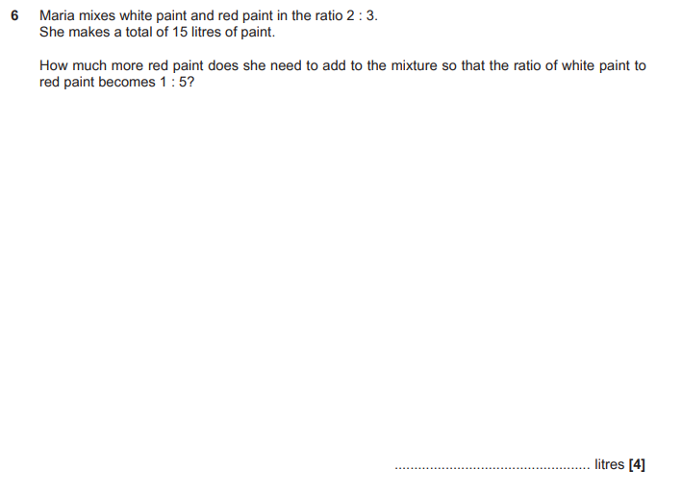

OCR GSCE – Tuesday 2 November 2017 – Paper 4 (Calculator) Higher Tier
72.
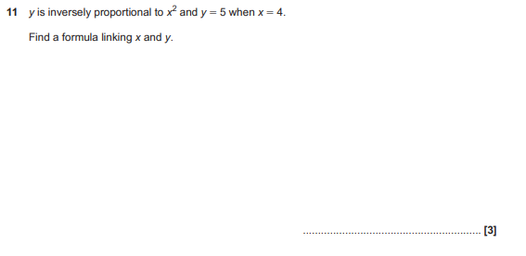
OCR GSCE – Tuesday 6 November 2017 – Paper 5 (Non - Calculator) Higher Tier
73.
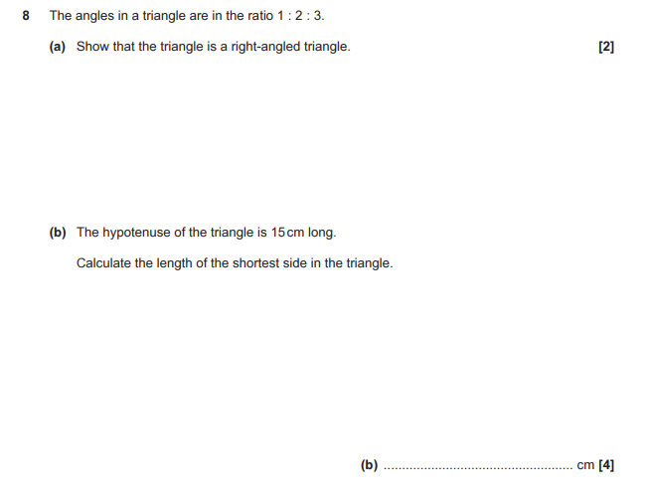

OCR GSCE – Tuesday 6 November 2017 – Paper 5 (Non - Calculator) Higher Tier
74.
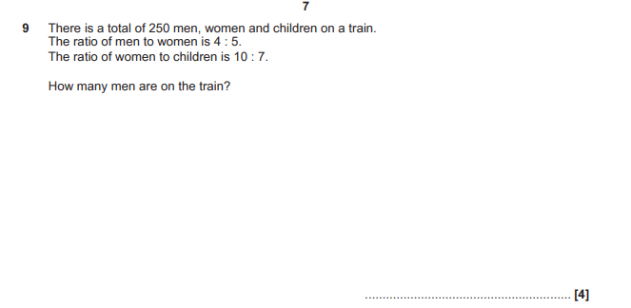

OCR GSCE – Wednesday 8 November 2017 – Paper 6 (Calculator) Higher Tier
75.
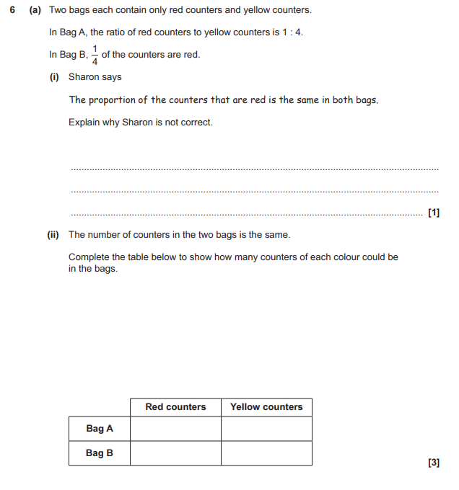

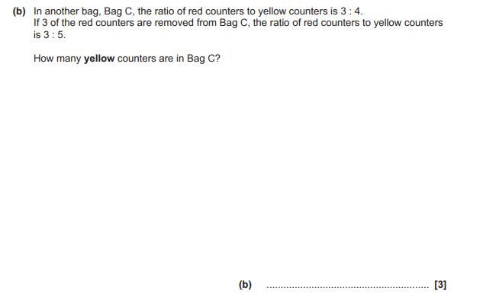

OCR GSCE – Wednesday 8 November 2017 – Paper 6 (Calculator) Higher Tier
76.
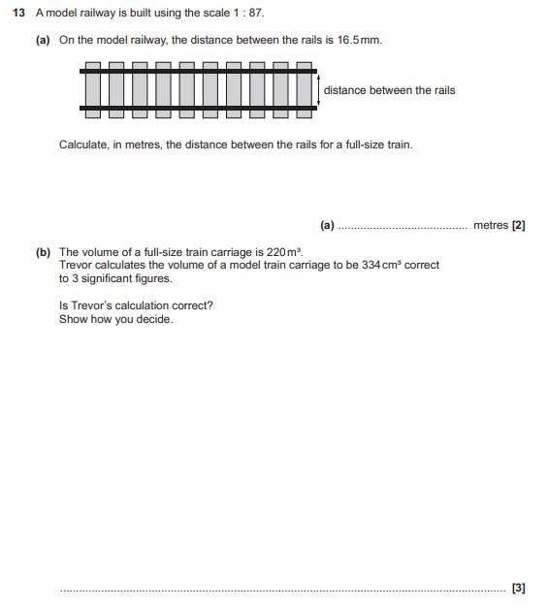

OCR GSCE – Thursday 8 June 2017 – Paper 5 (Non - Calculator) Higher Tier
77.
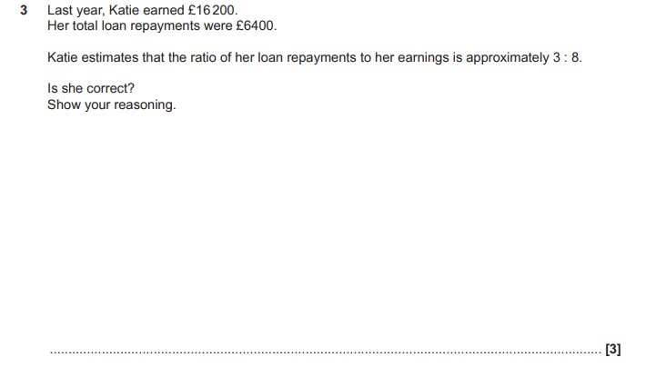

OCR GSCE – Thursday 8 June 2017 – Paper 5 (Non - Calculator) Higher Tier
78.
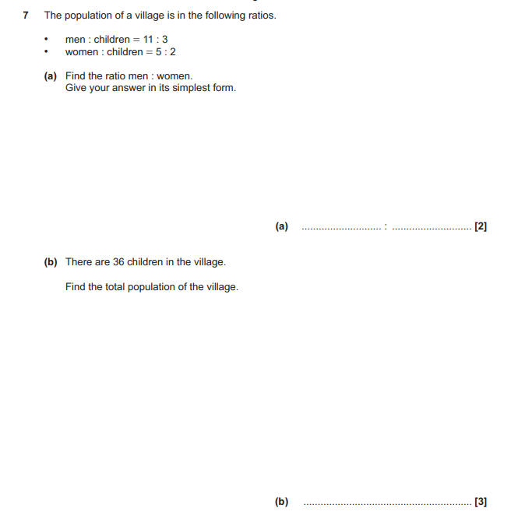

OCR GSCE – Tuesday 13 June 2017 – Paper 6 (Calculator) Higher Tier
79.
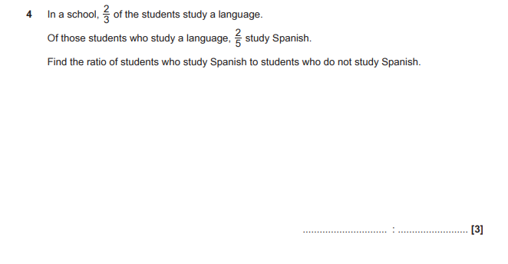
OCR GSCE – Tuesday 13 June 2017 – Paper 6 (Calculator) Higher Tier
80.
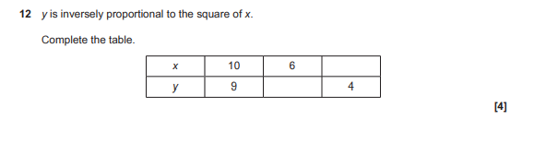

OCR GSCE – Sample Papers – Paper 4 (Calculator) Higher Tier
81.
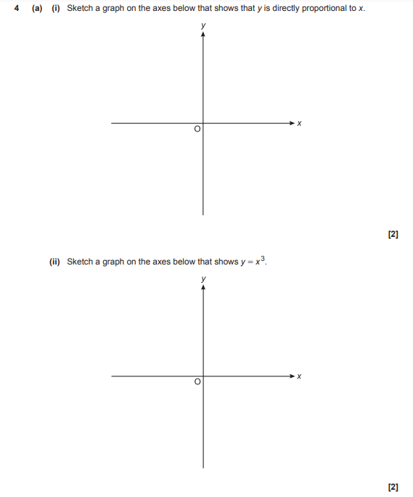

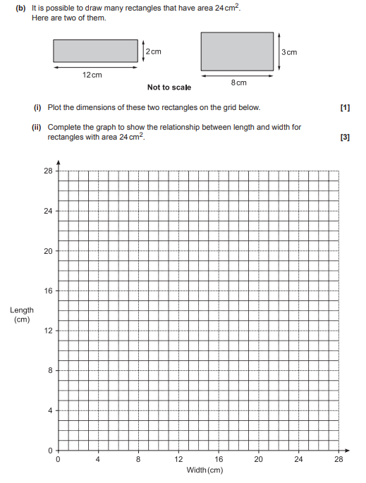

OCR GSCE – Sample Papers – Paper 4 (Calculator) Higher Tier
81.
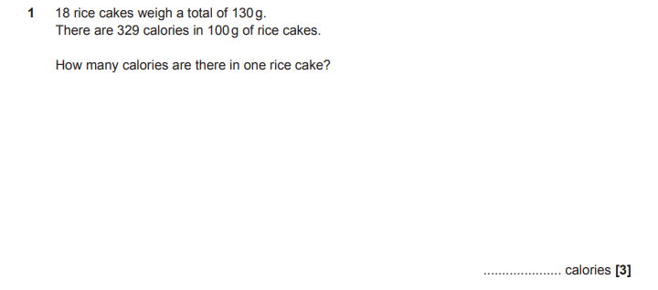

OCR GSCE – Sample Papers – Paper 5 (Non - Calculator) Higher Tier
82.
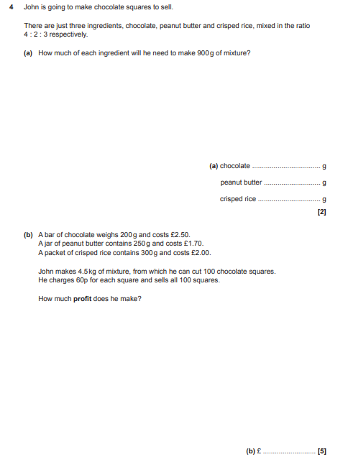

OCR GSCE – Sample Papers – Paper 5 (Non - Calculator) Higher Tier
83.
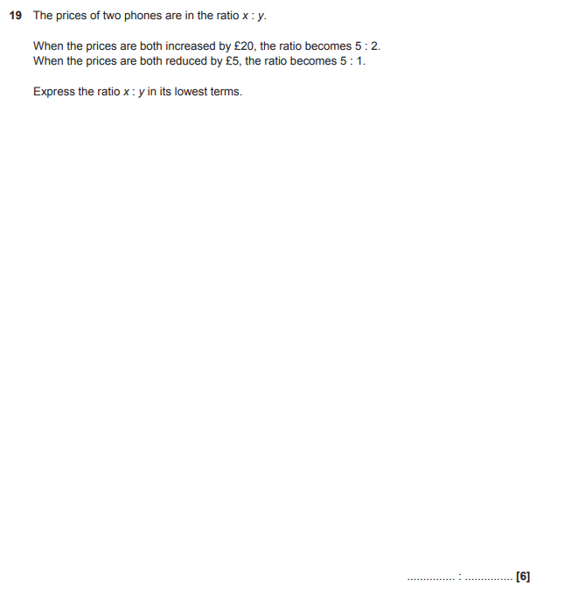

AQA GSCE – Tuesday 19 May 2020 – Paper 1 (Non - Calculator) Higher Tier
84.
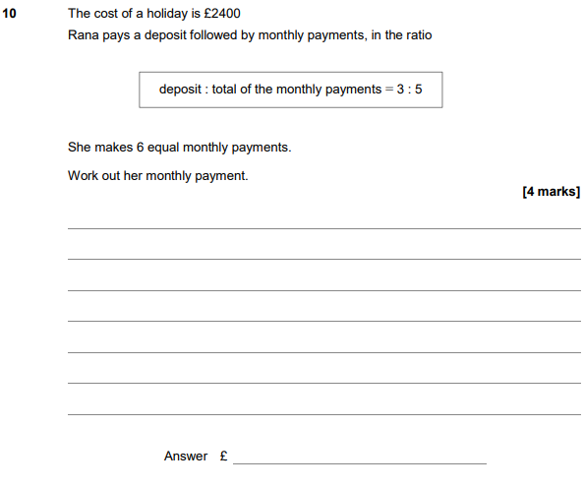

AQA GSCE – Tuesday 19 May 2020 – Paper 1 (Non - Calculator) Higher Tier
85.

AQA GSCE – Tuesday 19 May 2020 – Paper 1 (Non - Calculator) Higher Tier
86.
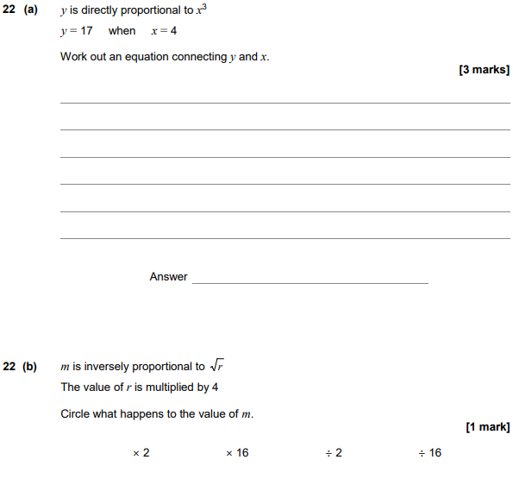

AQA GSCE – Thursday 4 June 2020 – Paper 2 (Calculator) Higher Tier
87.
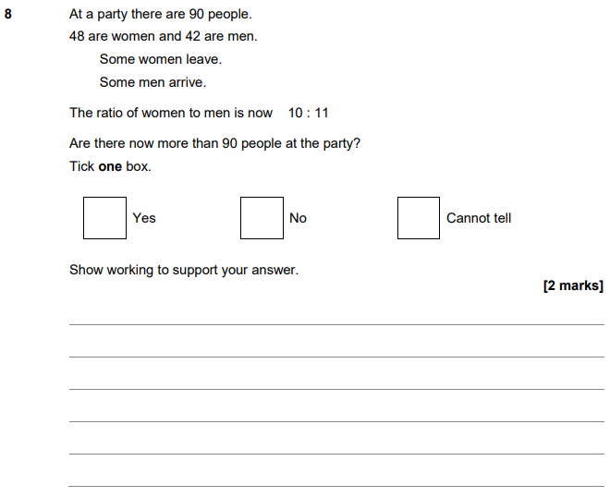

AQA GSCE – Tuesday 21 May 2019 – Paper 1 (Non - Calculator) Higher Tier
88.
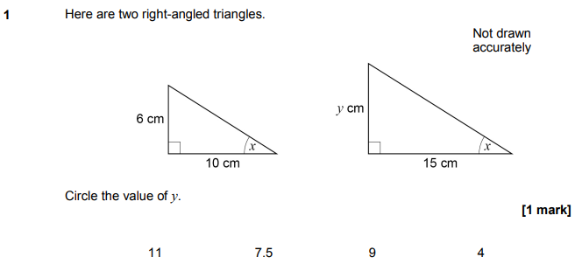
AQA GSCE – Tuesday 21 May 2019 – Paper 1 (Non - Calculator) Higher Tier
89.
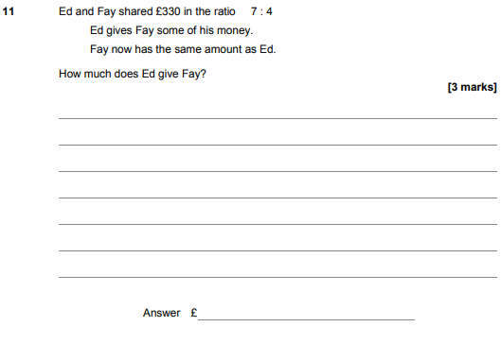

AQA GSCE – Thursday 6 June 2019 – Paper 2 (Calculator) Higher Tier
90.
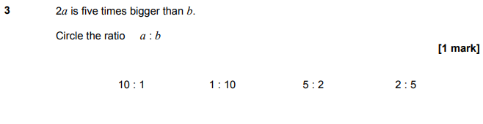
AQA GSCE – Thursday 6 June 2019 – Paper 2 (Calculator) Higher Tier
91.
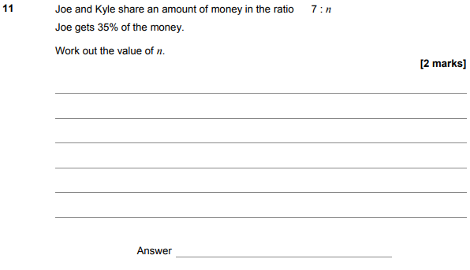

AQA GSCE – Tuesday 11 June 2019 – Paper 3 (Calculator) Higher Tier
92.
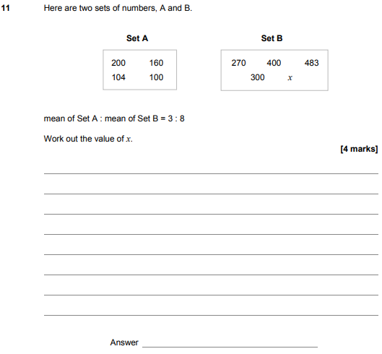

AQA GSCE – Tuesday 11 June 2019 – Paper 3 (Calculator) Higher Tier
93.
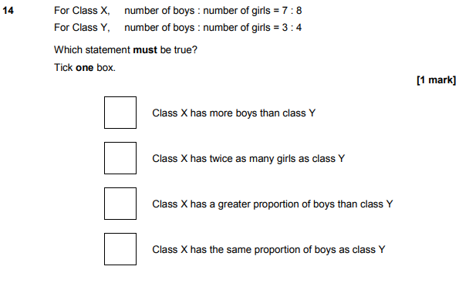

AQA GSCE – Tuesday 11 June 2019 – Paper 3 (Calculator) Higher Tier
94.
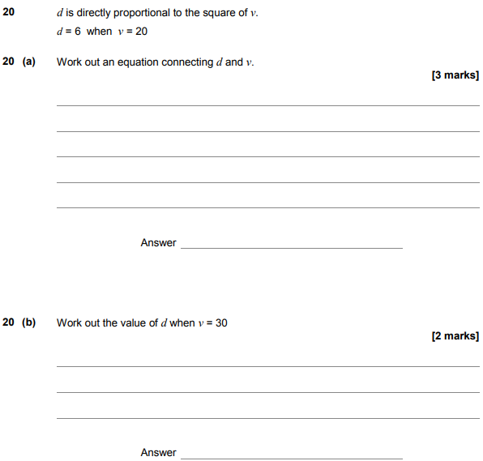

AQA GSCE – Tuesday 6 November 2018 – Paper 1 (Non - Calculator) Higher Tier
95.
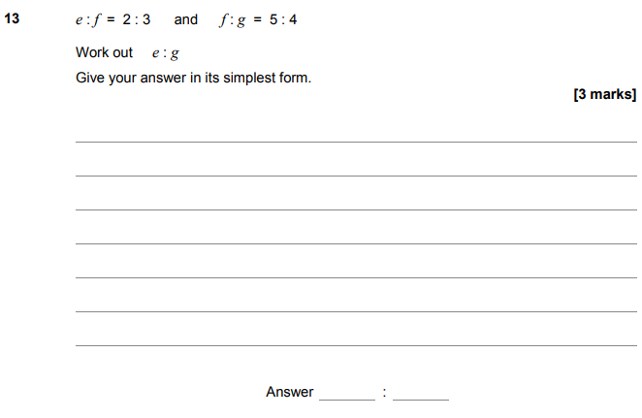

AQA GSCE – Tuesday 6 November 2018 – Paper 1 (Non - Calculator) Higher Tier
96.
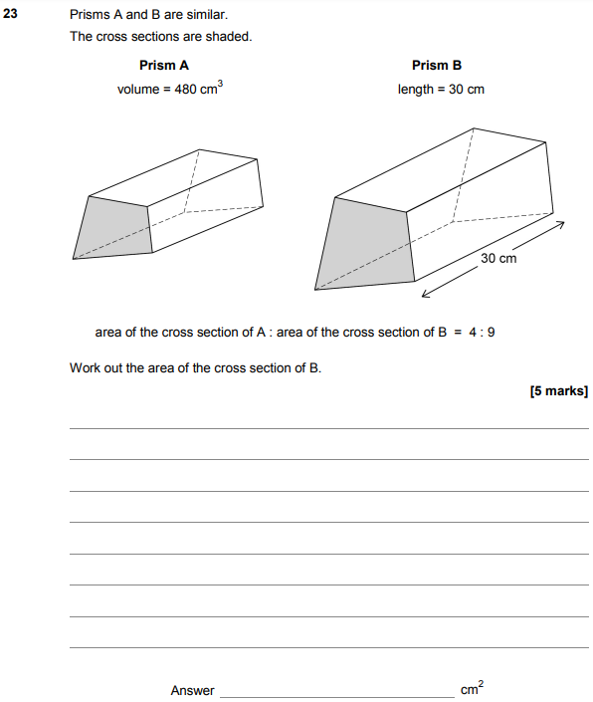

AQA GSCE – Thursday 8 November 2018 – Paper 2 (Calculator) Higher Tier
97.
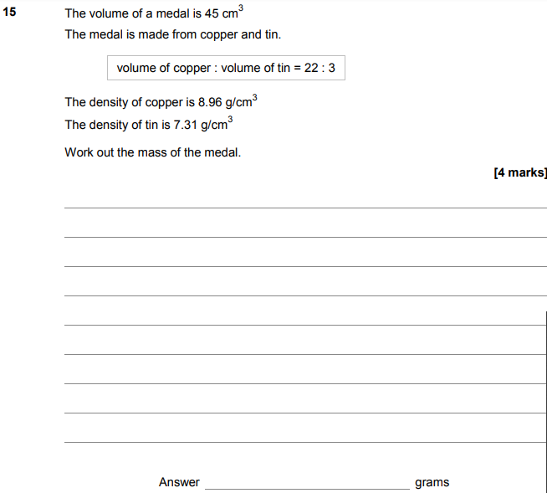

AQA GSCE – Thursday 8 November 2018 – Paper 2 (Calculator) Higher Tier
98.
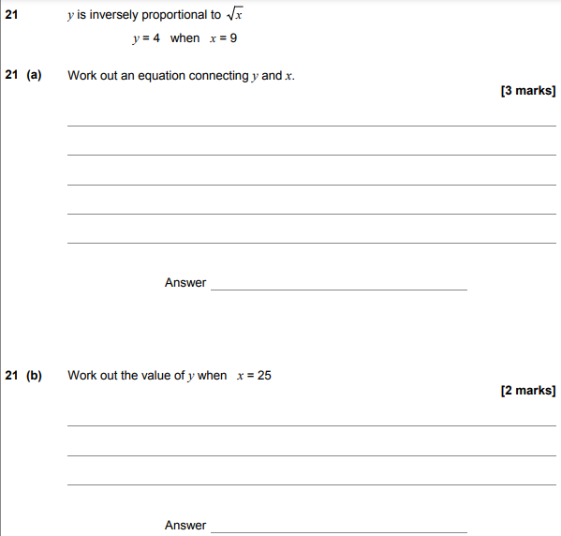

AQA GSCE – Monday 12 November 2018 – Paper 3 (Calculator) Higher Tier
99.
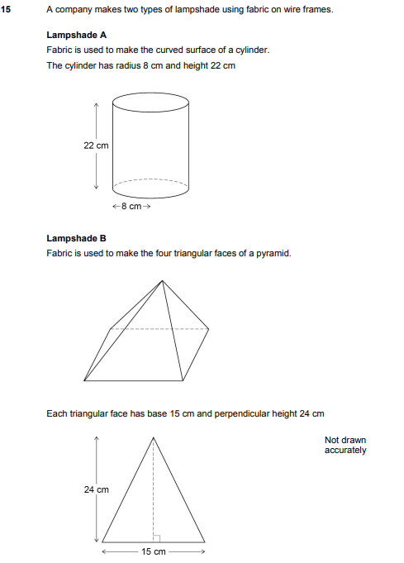
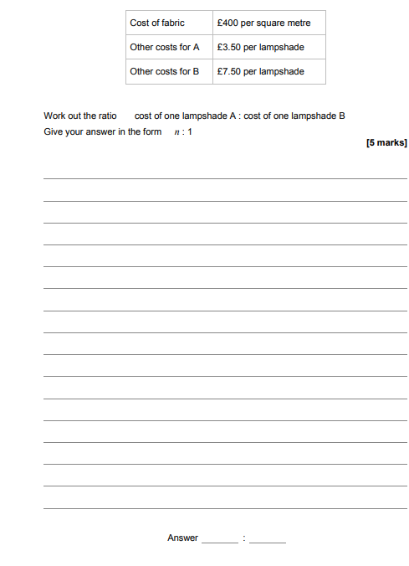

AQA GSCE – Monday 24 May 2018 – Paper 1 (Non - Calculator) Higher Tier
100.
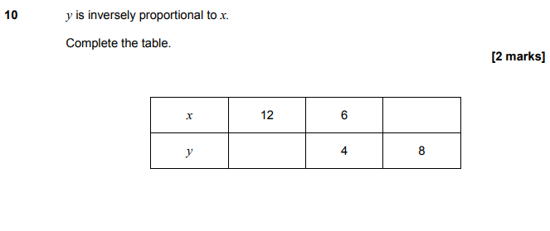
AQA GSCE – Monday 24 May 2018 – Paper 1 (Non - Calculator) Higher Tier
101.
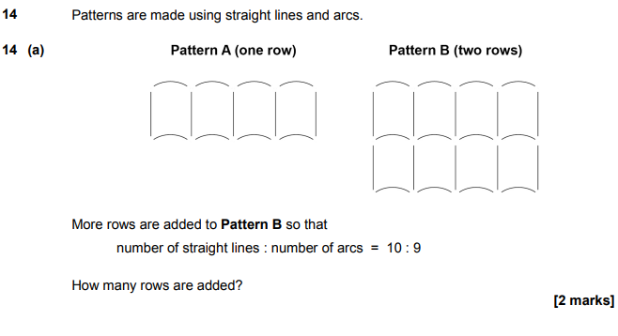
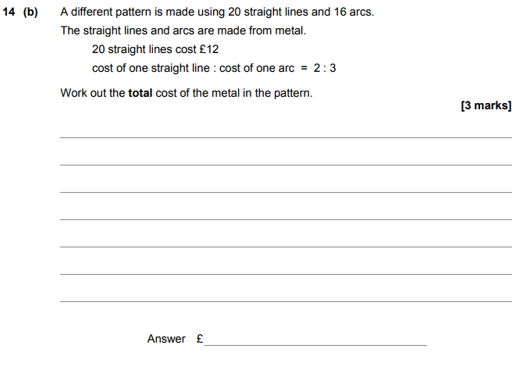
AQA GSCE – Monday 24 May 2018 – Paper 1 (Non - Calculator) Higher Tier
102.
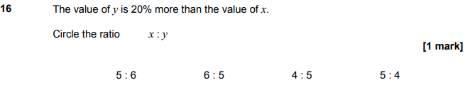

AQA GSCE – Monday 24 May 2018 – Paper 1 (Non - Calculator) Higher Tier
103.
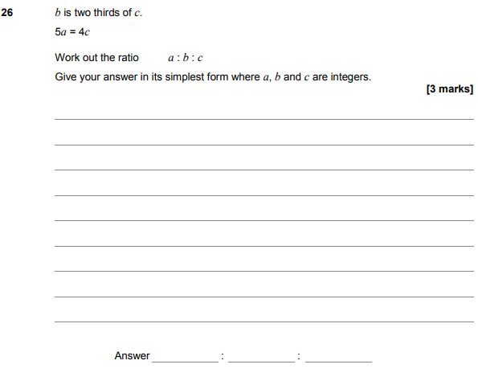

AQA GSCE – Thursday 7 June 2018 – Paper 2 (Calculator) Higher Tier
104.
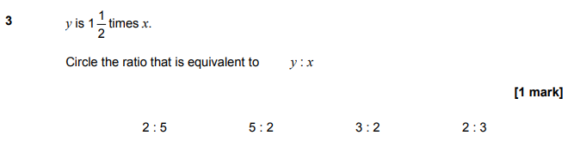
AQA GSCE – Thursday 7 June 2018 – Paper 2 (Calculator) Higher Tier
105.
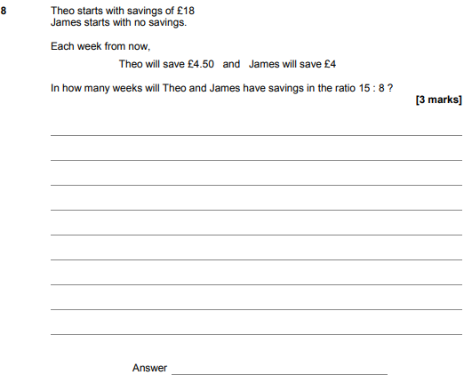

AQA GSCE – Thursday 2 November 2017 – Paper 1 (Non - Calculator) Higher Tier
106.
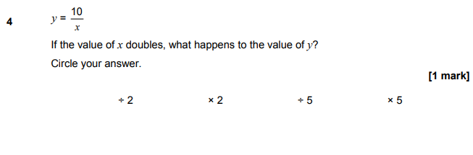
AQA GSCE – Thursday 2 November 2017 – Paper 1 (Non - Calculator) Higher Tier
107.
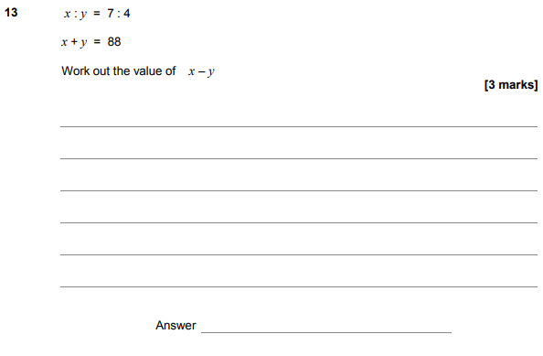

AQA GSCE – Thursday 6 November 2017 – Paper 2 (Calculator) Higher Tier
108.
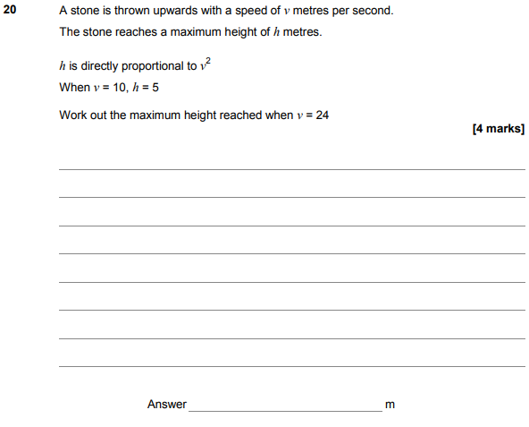

AQA GSCE – Wednesday 8 November 2017 – Paper 3 (Calculator) Higher Tier
109.
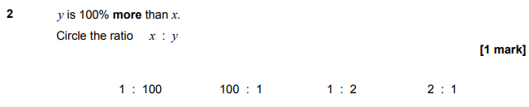
AQA GSCE – Wednesday 8 November 2017 – Paper 3 (Calculator) Higher Tier
110.
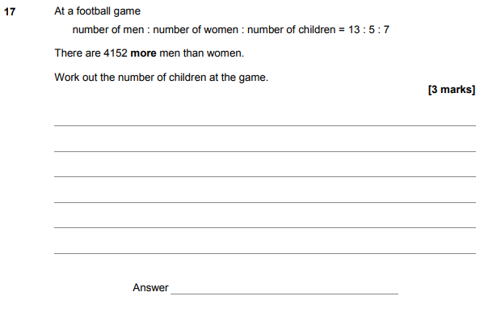

AQA GSCE – Wednesday 8 November 2017 – Paper 3 (Calculator) Higher Tier
111.
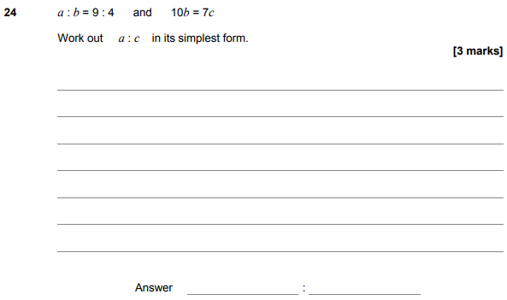
AQA GSCE – Wednesday 25 May 2017 – Paper 1 (Non - Calculator) Higher Tier
112.
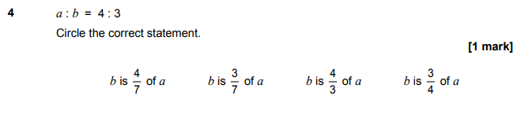
AQA GSCE – Thursday 8 June 2017 – Paper 2 (Calculator) Higher Tier
113.

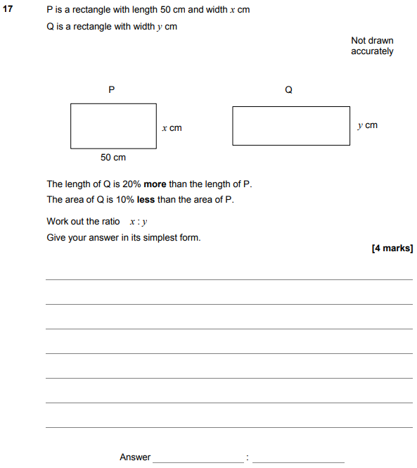

AQA GSCE – Thursday 8 June 2017 – Paper 2 (Calculator) Higher Tier
114.
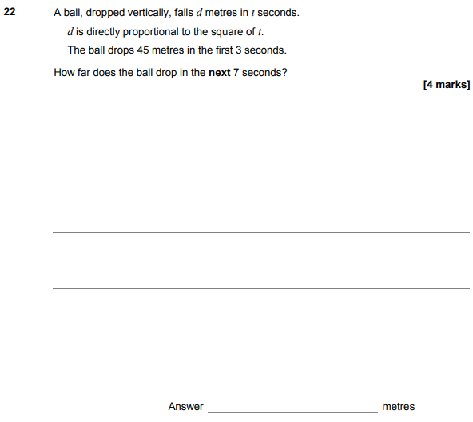

AQA GSCE – Tuesday 13 June 2017 – Paper 3 (Calculator) Higher Tier
115.
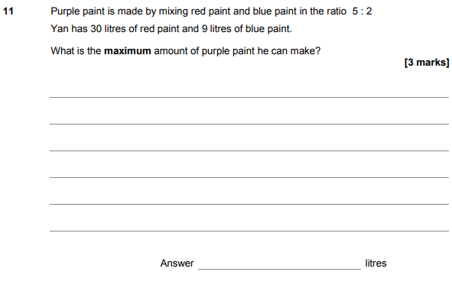
AQA GSCE – Tuesday 13 June 2017 – Paper 3 (Calculator) Higher Tier
116.
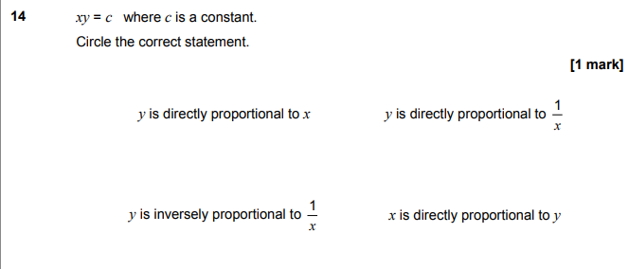

AQA GSCE – Sample Paper 1 (Non - Calculator) Higher Tier
117.
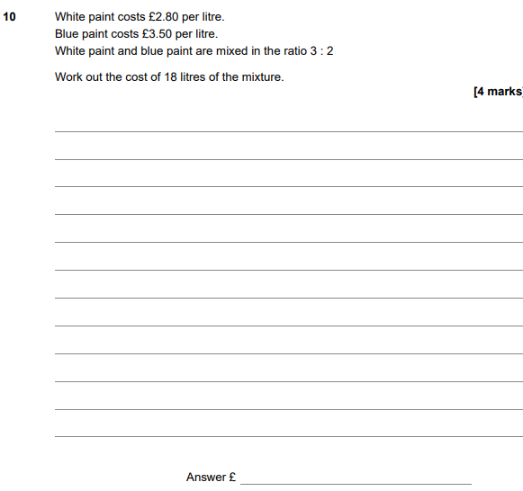

AQA GSCE – Sample Paper 2 (Calculator) Higher Tier
119.
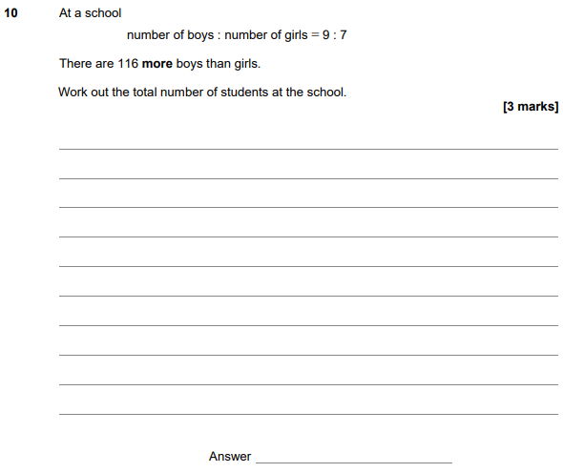

AQA GSCE – Sample Paper 2 (Calculator) Higher Tier
120.
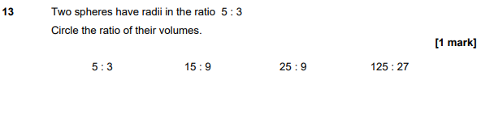
AQA GSCE – Sample Paper 2 (Calculator) Higher Tier
121.
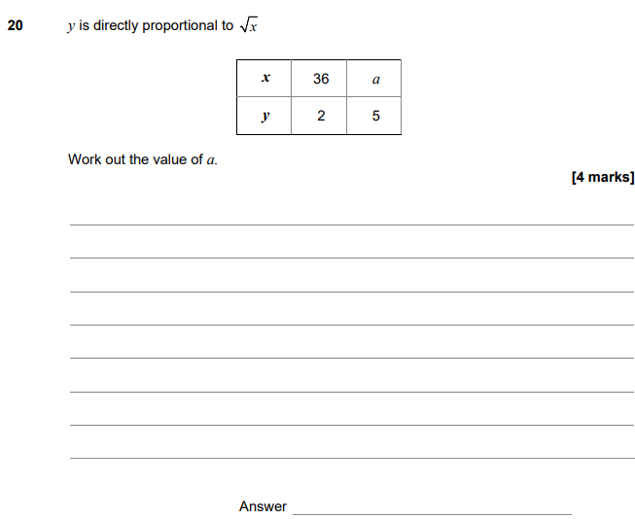

AQA GSCE – Sample Paper 3 (Calculator) Higher Tier
122.
